**Game Idea [Futuristic]**

First Person Shooter game with RPG element to it.

A world is splitted into Good Robots and Bad Robots.

Good Robots being locked in an unknown space.

You are being left in a place full of darkness.

Having no clue of where you are, you wandered around, looking for the exit.

P.S This might be a **HORROR** game.

**Gameplay**

**Game Objective:**

Every scene will have a certain time limit.

Exit point or scene objective must be completed before time limit, else, game over.

Player is to clear all the predefined levels to complete the game.

A boss level happens every 2 levels is completed.

**Enemy:**

Bad robots [enemy] will be placed around the field.

When player reached a certain range of the enemy, the enemy will start moving towards the player.

Player can either move away from the enemy or defeat the enemy by attacking.

Each enemy will have a predefined health power [HP] and attack power [AP].

Depleting the enemy’s HP to 0 will delete it from the scene.

**Support:**

Electrical field; to heal Health Power [HP] and Torchlight Battery [TB].

Teleporters; teleport player to another part of the map.

**Unique Selling Point**

Collation of multiple genres into one.

**Features**

**Game Mechanics:**

* Different type of weapons; gun, sword and fist.
* Time limit for each level.
* NPC to interact with; purchasing of weapons and items.
* Lava platform; instant death upon stepping.
* Torchlight; increase visibility of map.
* Speed Battery [increases movement speed]; speed increases for a certain time frame when collected.
* Movement of character using mouse/keyboard.

**User Interface [UI]:**

* Screen flicker red when health is being reduced.
* HP on the top left of the screen.
* TB positioned below the HP.
* Amount of enemies left positioned at bottom left of the screen.

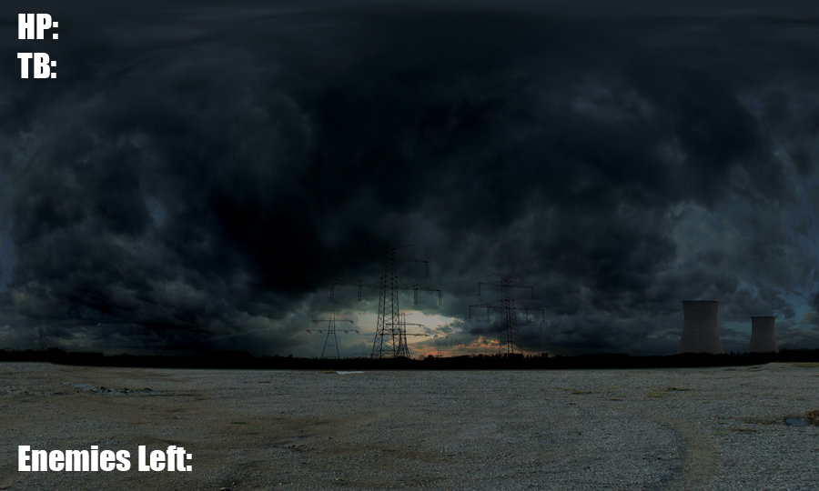

* Pressing ‘I’ will bring up inventory.
  + Weapons or items can be used from the inventory.

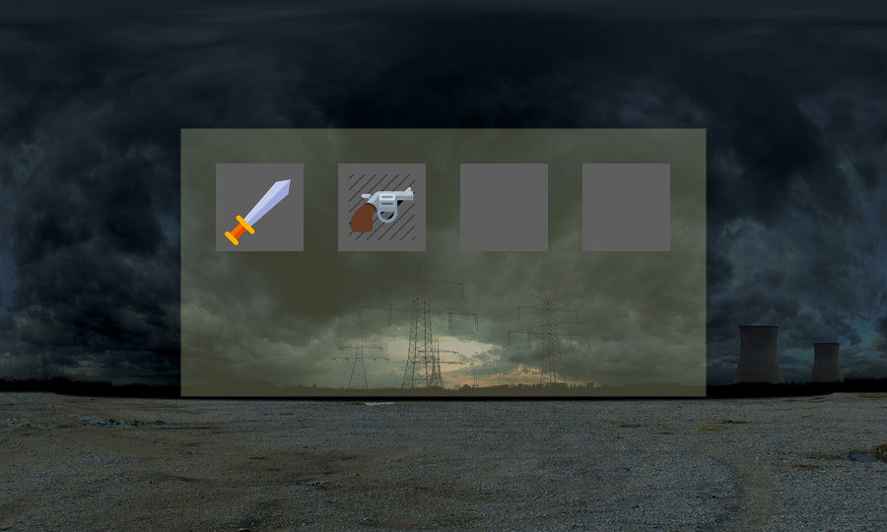

**Tasks**

**AGILE FRAMEWORK WILL BE USED; Tasks interchangeable.**

**Everyone:**

* Projectile
  + Create an object for projectile
  + Make projectile appears when keypress
  + Moves projectile forward
  + Detect if projectile touches enemy [object]
  + Deleting projectile when touched
  + Depleting HP of enemy when projectile touches
* User Interface
  + Splash Screen
    - Display Team Name
  + Main Menu
    - New Game
    - Load Game
    - Instructions
    - Exit
  + Pause Menu
    - Continue
    - Restart
    - Exit
  + Game Screen
    - Health Power [Left Top]
    - Torch Battery [Below HP]
    - Enemies Left [Bottom Left]
  + Inventory
    - Translucent background
    - Square spacing for item icons
    - Esc for closing inventory
* Story
  + Tutorial Level
  + Level 1
  + Level 2
  + Level 3
  + Level 4
  + Boss/Bonus Level
* Save Game/Load Game
  + Saving values to a text file
  + Reading the values from text file
  + Check if values from text file is equal to a certain condition in code
  + Load the game scene according to the condition
* Tutorial Level
  + Displaying instructions on controls
    - Wall displaying WASD for Movement
    - Prompt press ‘E’ to pick torchlight when player approaches a torchlight
  + Trap an enemy in a cage looking object
    - Displaying “This is your enemy” when player approaches it
* Boss/Bonus Level
  + Huge boss character model

**Beckham:**

* Inventory
  + Storing of item to a class
* Level 3

**Eugene:**

* Collision detection
  + Detect if next position is an object
  + Prevent camera from moving if next position is an object
* Jumping for player
  + Increase position.y when spacebar is pressed
  + Decrease position.y to 0 when position.y > 0
* Binding of weapon to player
  + If player is in a certain range of an object, enable keypress ‘E’
  + Translate and Rotate weapon to camera
* Level 4

**Ming Xiu:**

* Enemy [Model]
  + Different enemy model for different levels
  + Hierarchical binding of body parts
* Enemy [Movement]
  + Random
  + Defined movement
    - Rotating arms
    - Rotating legs
* Level 1

**Yoong Soon:**

* Enemy [AI range detection]
* Enemy [Pathfinding]
* Level 2

**Project Schedule**

**Week 1:**

* Basic mechanics
  + Unable to walk through objects and walls.
  + HP dealing system; Hit enemy, enemy.hp-- Being hit by enemy, my.hp--
  + Time limit; game over.
  + Inventory; changing of weapons and healing HP when recovery item is used.
  + Transferring of one scene to another scene.
  + All levels to be properly rendered and working.

**Week 2:**

* Addon features
  + Save Game/Load Game
  + To be confirmed.
* Debugging.
* Play time test.

**Week 3:**

* Polishing of features.
* Ensuring game is bug free or close to bug free.
* Documentation of game.